**Functional Requirements Document**

**The Blaugranes**

**UofR Student Hub**

**01/11/2019**

**Ufuoma Aya**

**Anirudh Bindal**

**Kyle Jakob Labatete**

**Sopuruchukwu Gift Ugwuonah**

|  |  |  |  |
| --- | --- | --- | --- |
| **Version** | **Description of Change** | **Author** | **Date** |
| 1 | FRD Creation | Ufuoma Aya | 23/10/2019 |
| 2 | Updated for Milestone 3 | Ufuoma Aya | 01/11/2019 |
| 3 | Updated for Milestone 4 | Ufuoma Aya | 04/12/2019 |

**CONTENTS**

1 INTRODUCTION 4

1.1 Purpose 4

1.2 Scope 4

1.3 Background 4

1.4 References 4

1.5 Assumptions and Constraints 4

1.6 Document Overview 5

2 METHODOLOGY 5

3 FUNCTIONAL REQUIREMENTS 5

4.1 Context 5

4.2 User Requirements 5

4.3 Data Flow Diagrams 6

4.4 Logical Data Model/Data Dictionary 6

4.5 Functional Requirements 6

5 OTHER REQUIREMENTS 6

5.1 Interface Requirements 6

5.2 Data Conversion Requirements 7

5.3 Hardware/Software Requirements 7

5.4 Operational Requirements 7

APPENDIX A - GLOSSARY 11

1. **INTRODUCTION**

## **Purpose**

The purpose of UofR Student Hub website is to provide a safe and educative platform where students who are currently enrolled in a program at the University of Regina can learn and exchange knowledge in an interactive and fun approach.

This document will provide detailed information on the functional requirements available to accomplish this task. Discussions on the architectural approach will be provided. Also, it will provide guidelines on the procedures needed to be taken to ensure a successful functional website.

## **Scope**

This document will help the team and users have a better understanding on the functionalities of our website. It will provide clear details of what is needed for the website to work, the processes and measures implemented that makes the website work and functionalities of the website.

This is achieved by comprehensively detailing the several needs of our website and providing a process of solving these needs. To improve the quality and functionalities of our website, modifications will be implemented, therefore, our website is subjected to changes in the nearest future.

## **Background**

We are a team of four, collectively known as The Blaugranes. The members are Ufuoma Aya, Anirudh Bindal, Kyle Jakob Labatete and Sopuruchukwu Gift Ugwuonah. It is our commitment to design and develop a website or minimum viable product (login, registration and department webpages) before the intended due date. As such, we have divided the development process to achieving this goal and each member has been assigned to a particular task.

This document will provide useful and necessary information needed to help understand the project’s scope and architecture.

## **References**

<https://github.com/Blaugranes/UofR-Student-Hub/tree/master/UML>

<https://github.com/Blaugranes/UofR-Student-Hub/blob/master/Lo-Fidelity%20Prototype.pdf>

<https://github.com/Blaugranes/UofR-Student-Hub/blob/master/MVC%20-%20MileStone%202.pptx>

<https://github.com/Blaugranes/UofR-Student-Hub/projects/1>

## **Assumptions and Constraints**

### **Assumptions**

This document assumes that required users are students currently enrolled in a program at the University of Regina.

### **Constraints**

* Slow website development as a result of limited knowledge in programming languages newly introduced to group members.
* Completion of milestones and required documents must not exceed the provided due dates.
* Milestone 1 must be completed by 2 October, 2019.
* Milestone 2 must be completed by 23 October, 2019.
* Milestone 3 must be completed by 13 November, 2019.
* Milestone 4 must be completed by 4 December, 2019.
* Finding a suitable time for group meetings that works with each member’s schedule.

## **Document Overview**

This document will provide a clarifying explanation on the current processes, plans, architectural designs, requirements and limitations of the development of our website . It will contain discussions of what the functional requirements are, the processes and measures taken, the implementation of architectural designs and correlations to the project. Also, we will detail the guiding principles and importance behind our website’s security and privacy, audit trail, reliability, recoverability, and error handling as well as other needs such as supported interfaces and hardwares.

1. **METHODOLOGY**

Problems may arise in the development process of our website, the team will brainstorm and develop solutions to deal with these problems. The solutions will be implemented, therefore, continuously implementing modifications to our website. This document will also outline modifications implemented for the improvement of already existing functionalities and addition of new functionalities.

1. **FUNCTIONAL REQUIREMENTS**

**3.1 Signup Page**

Users will be required to provide information which will be used to create an account for our website. This information includes: first name, last name, username, email, password and faculty.

**3.2 Login Page**

Users will be required to use the login information (username and password) they provided in the signup page to gain access to our website. If they do not already have an account, they will be required to create one.

**3.3 Home Page**

This is the general page where users from all faculties can create, comment and vote on threads. Also, there is an upcoming events section so users can be informed about events going on at the University of Regina.

**3.4 Faculty Page**

This is the page where users enrolled in a specific program and corresponding faculties can create, comment and vote on threads. Also, there is an upcoming events section so users can be informed about events going on in their specified faculties.

**3.5 Profile Page**

This is the page where users can provide useful details to their profile e.g username, profile photo, password change e.t.c.

1. **Project Architecture**

## Low Fidelity Prototype

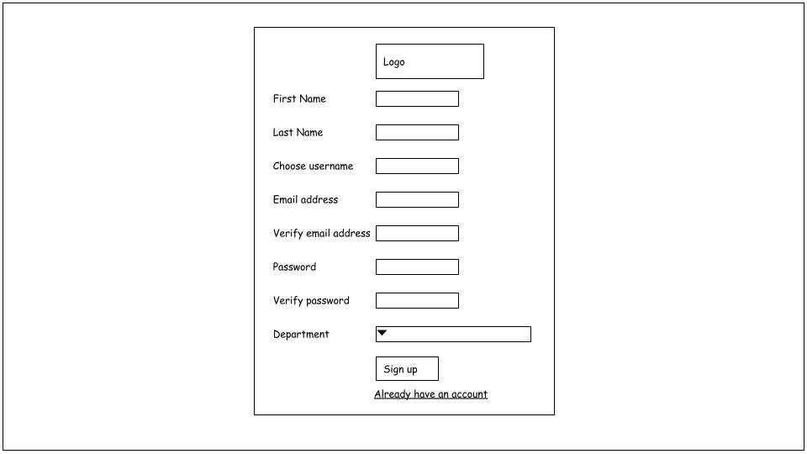

Figure 4.1.1 Signup page

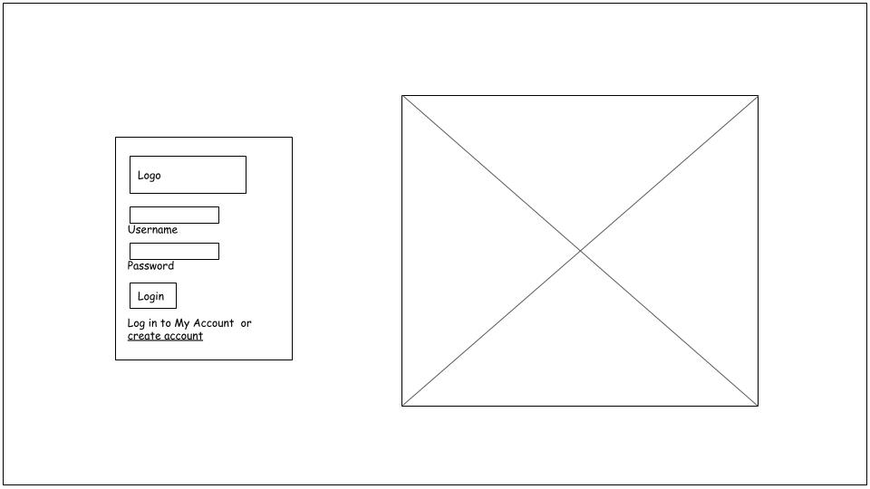

Figure 4.1.2 Login page

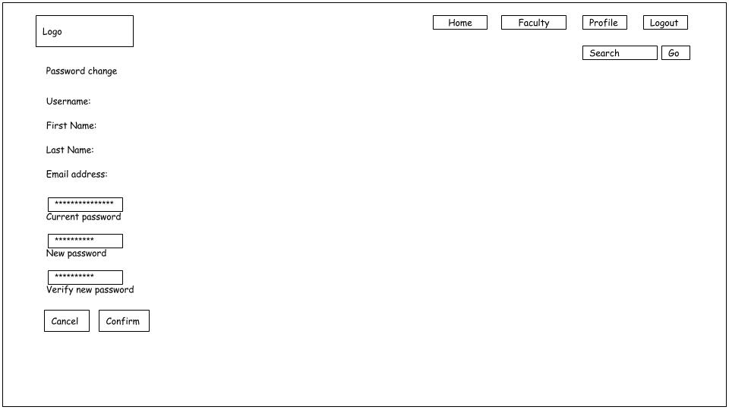

Figure 4.1.3 Profile page

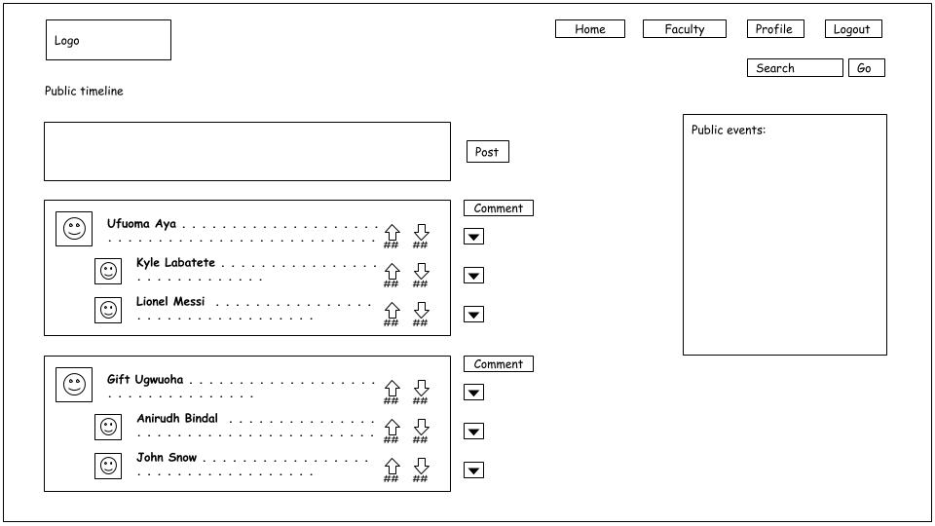

Figure 4.1.4 Home page

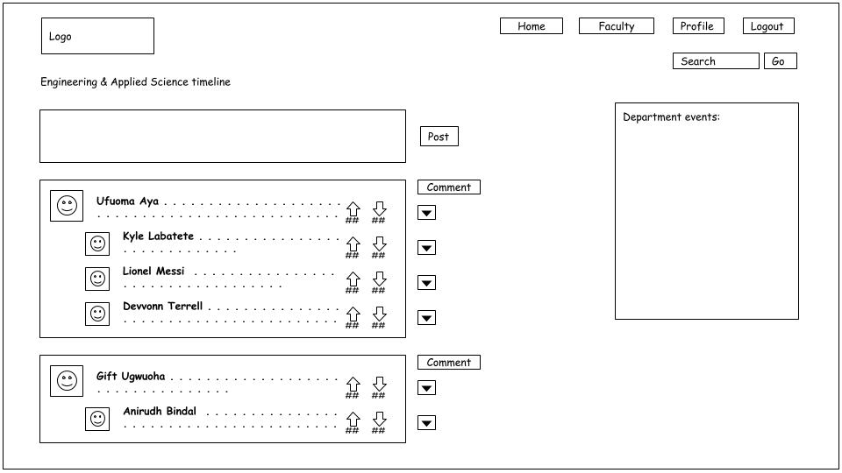

Figure 4.1.5 Faculty page

## High Fidelity Prototype

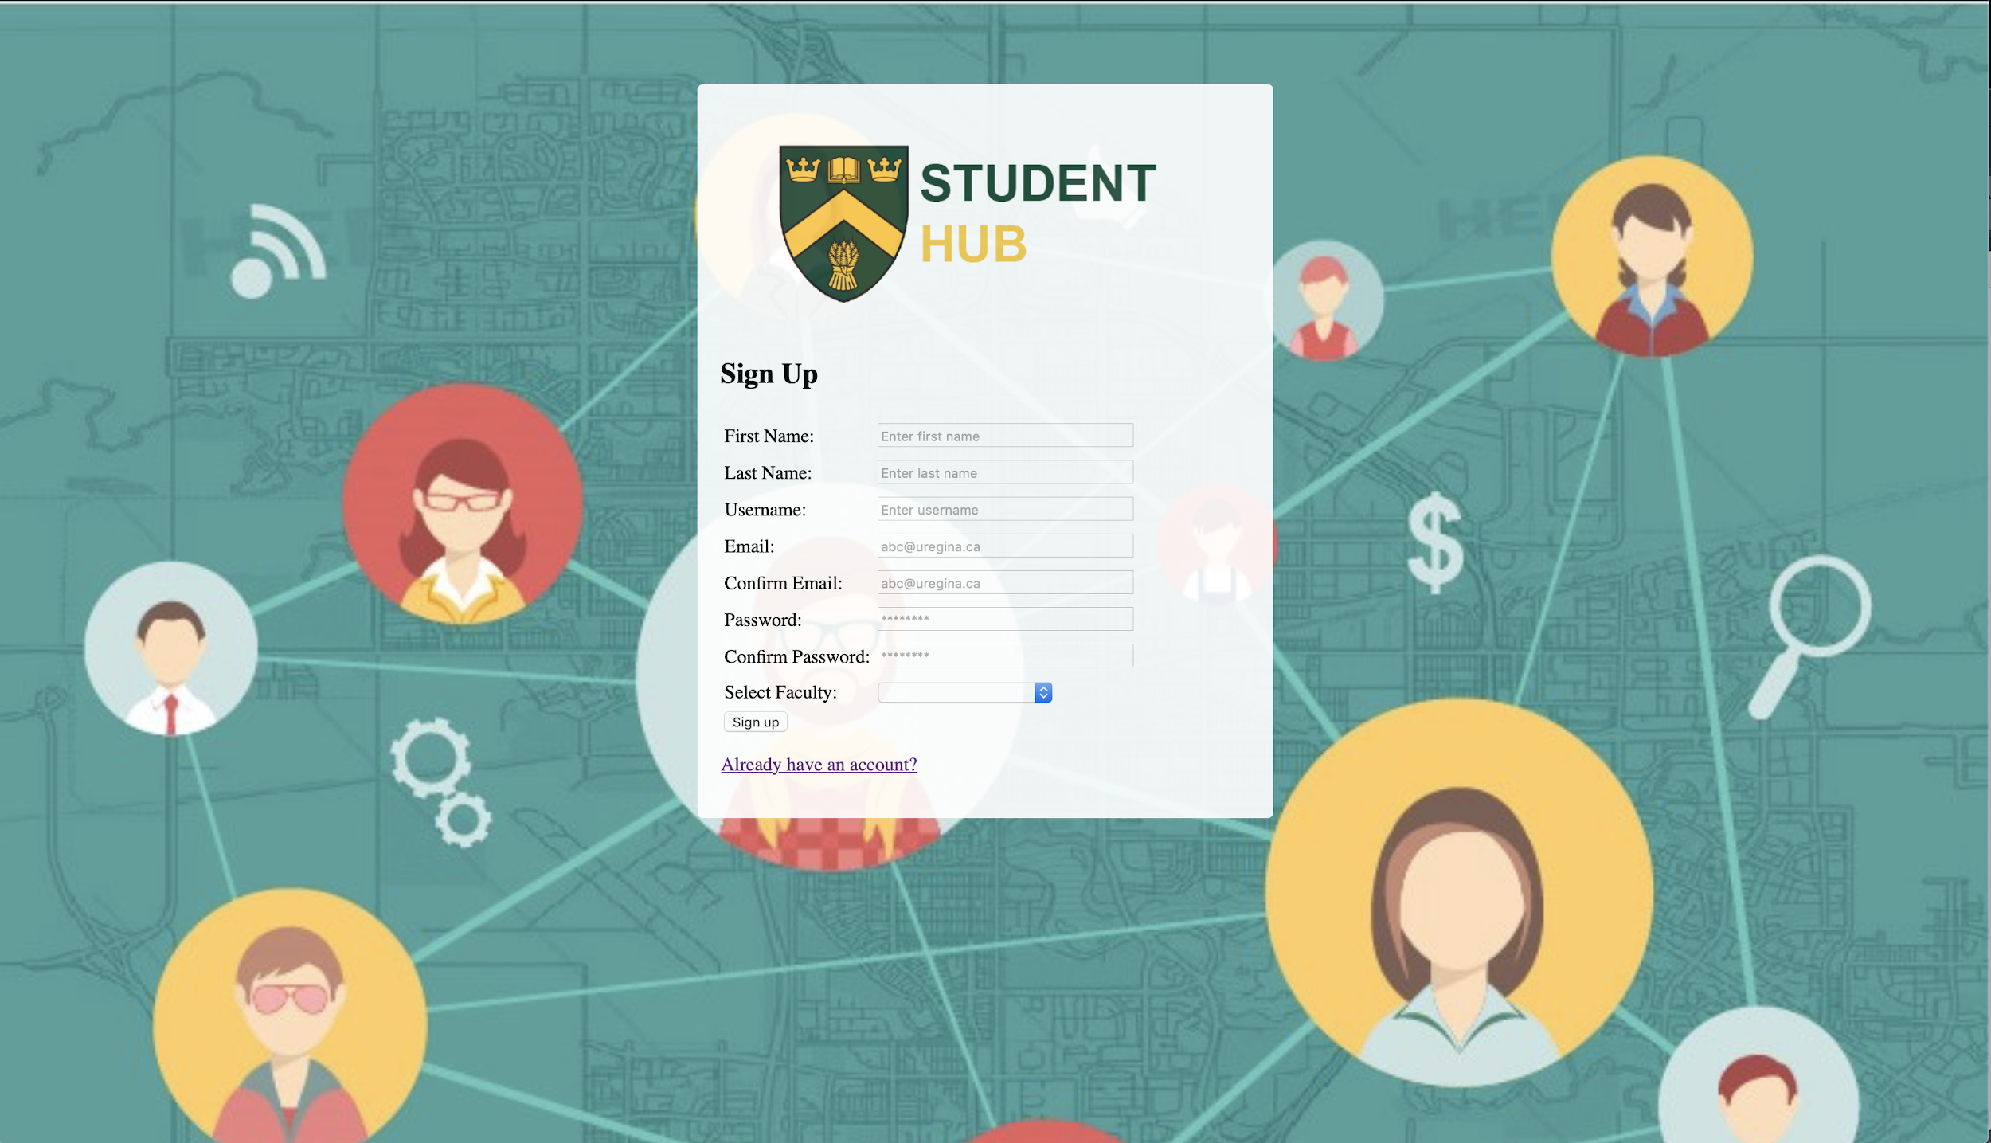

Figure 4.2.1 Signup page

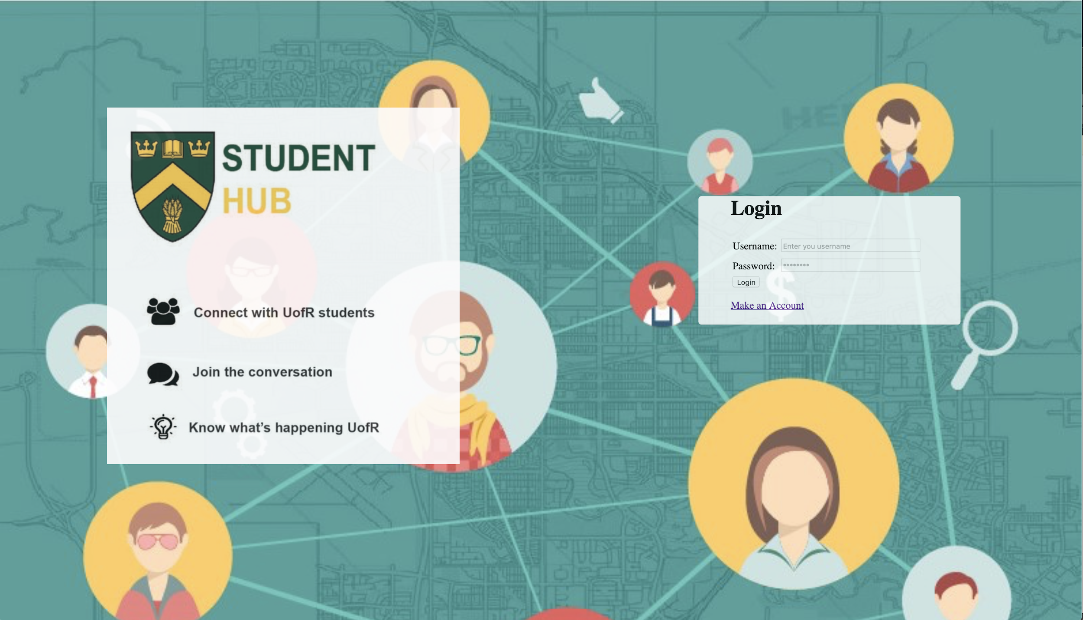

Figure 4.2.2 Login page

## User Requirements

Our website is only valid for students currently enrolled in a program at the University of Regina. User should be able to create discussion threads, comment and vote on already existing discussion threads.

Users should be able to access the general university’s public page, the page of their respective department and also, be able to view upcoming events on the general public and department pages.

Users should be able to receive notifications, these notifications should result from one of the following: a new discussion thread added on the department page, a new comment added to a discussion thread being followed by the user, a vote added casted on a discussion thread or comment and an upcoming event.

For minimum viable product, users should be able to access the registration webpage and will be required to provide necessary information (including their respective departments) to successfully register to the website. After registration is completed, users should be able to successfully login to the website to gain access to the public page and their respective department page.

## **Data Flow Diagrams**

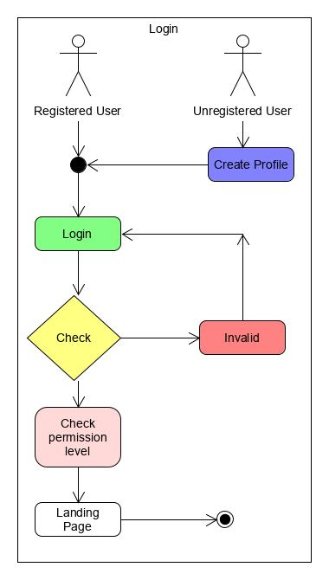

Figure 4.2.1 Login data flow diagram

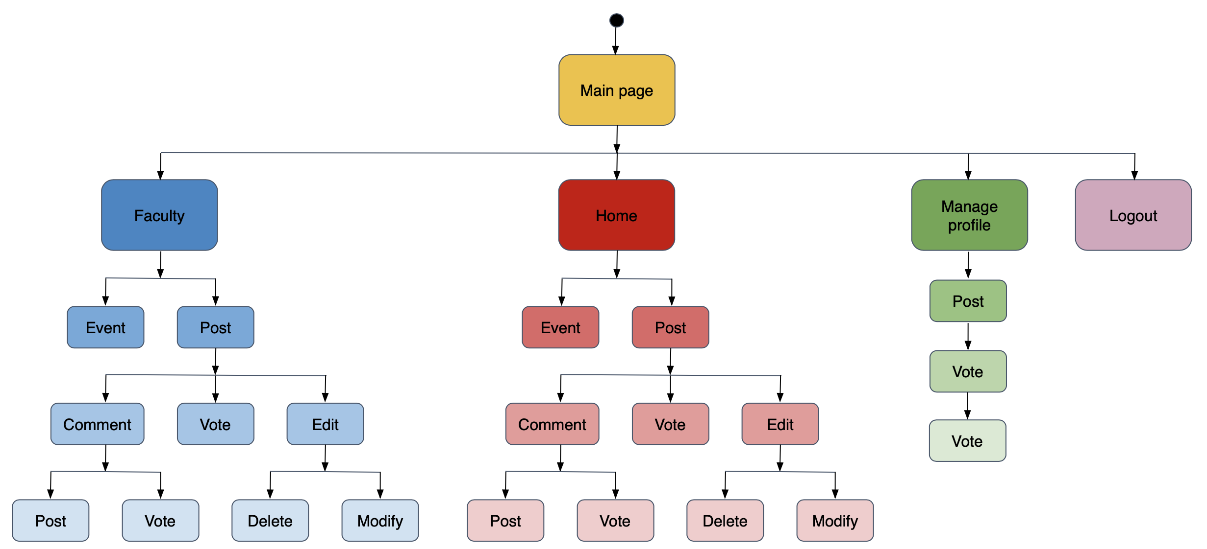

4.2.2 Main data flow diagram

## MVC Architecture

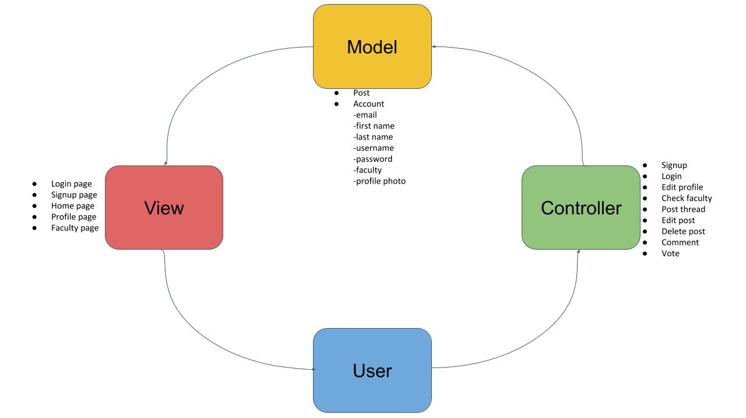

Figure 4.5 MVC Diagram

## **Logical Data Model/Data Dictionary**

Class diagram is subjected to modifications in the future.

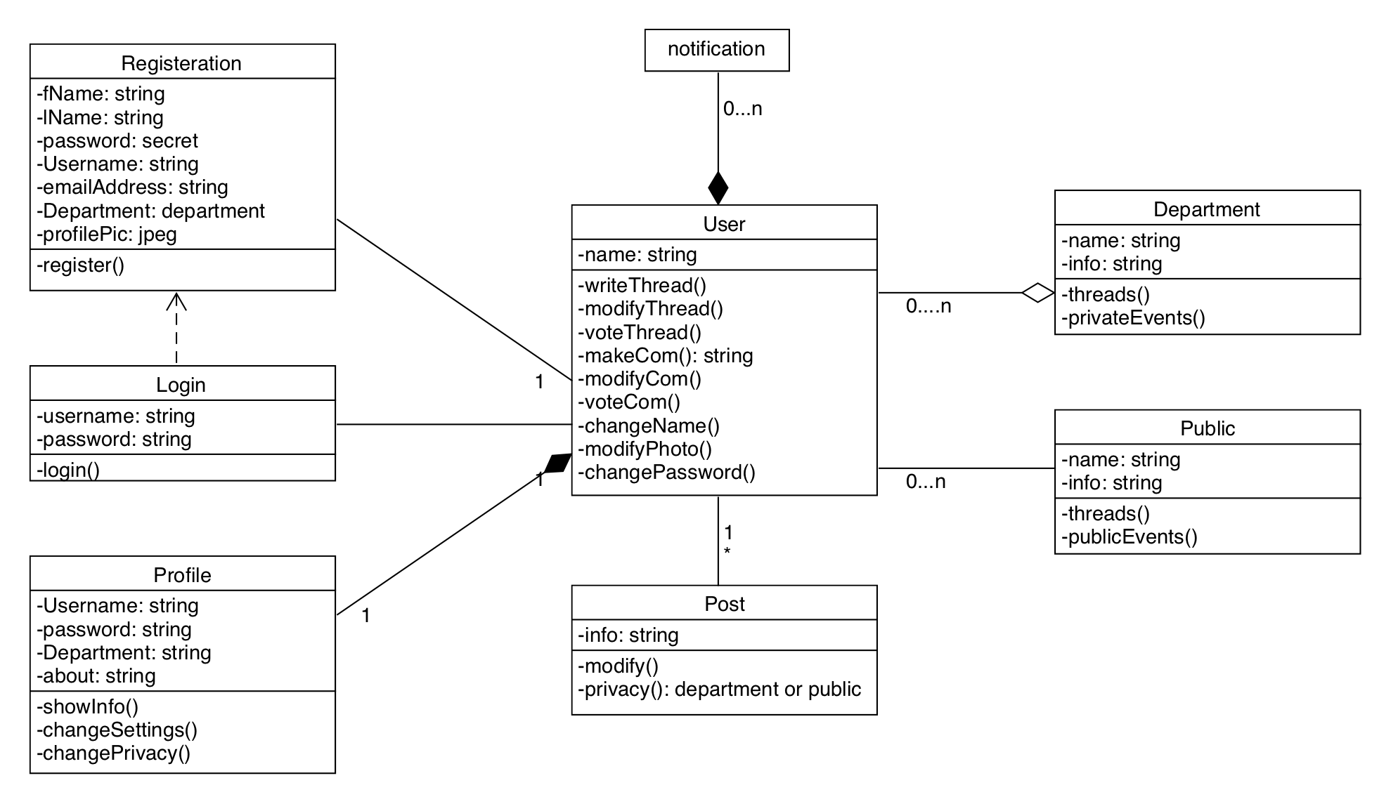

Figure 4.4 Class diagram

1. **OTHER REQUIREMENTS**

## **Interface Requirements**

Users should be able to interface with the website via a supported web browser.

### **Hardware Interfaces**

Several tests have been carried out on both computers and mobile devices. Although these devices should be able to interface with our website via supported web browsers, the mobile version needs to be modified to be fully compatible with several screen sizes.

## **Data Conversion Requirements**

Data conversion requirements were not applicable for the development of our website.

## **Hardware/Software Requirements**

For this project, we use CSS and PHP as the software requirements for designing the website. For users to access the website, the software requirement is a web browser. For record keeping and database management, MySQL is our preferred choice.

## **Operational Requirements**

### **Security and Privacy**

A. Consequences of the following breaches of security in the subject application:

1. Loss or corruption of data

* Minimal consequences expected. No breaches in privacy.

1. Disclosure of secrets or sensitive information

* No foreseeable reason for users’ personal information to be disclosed to attackers.

1. Disclosure of privileged/privacy information about individuals

* No foreseeable reason for users private information to be disclosed to external sources such as hackers.

1. Corruption of software or introduction of malware, such as viruses

* We will ensure the inability of external sources such as hackers to gain control of our website.

### **Reliability**

If there exists a performance failure in our website, we will define the cause and work on developing a solution. Users should able to lookup and access alternative solutions.

**APPENDIX A - GLOSSARY**

CSS: Cascading Style Sheet, used to format the layout of webpages.

FRD: Functional Requirements Document.

JS: Java Script, an object-oriented computer programming language commonly used to create interactive effects within web browsers.

MVC: Model View Controller, “an application design model comprised of three interconnected parts. It includes the model (data), the view (interface), and controller (processes).

MVP: Minimum Viable Product, the smallest possible product whose function is still viable for users.

PHP: Hypertext Preprocessor, used to develop static websites or dynamic website or web applications.

SQL: Structure Query Language.